Find & Track Scholarships Reference Guide

Overview
Naviance Student provides tools for locating scholarship opportunities and keeping track of those to which you have applied.

Finding a Scholarship
Scholarship tools can be found by navigating to Colleges Home > Scholarships & Money.

Scholarship List
A list of potentially relevant scholarships that you can review and add to your applications list. Use Filters to search by categories that your school has identified. Use the Only show new since my last visit checkbox to keep track of new scholarship offerings. Select the checkbox next to a scholarship and then click Add to My Applications if you have or will apply to that scholarship.
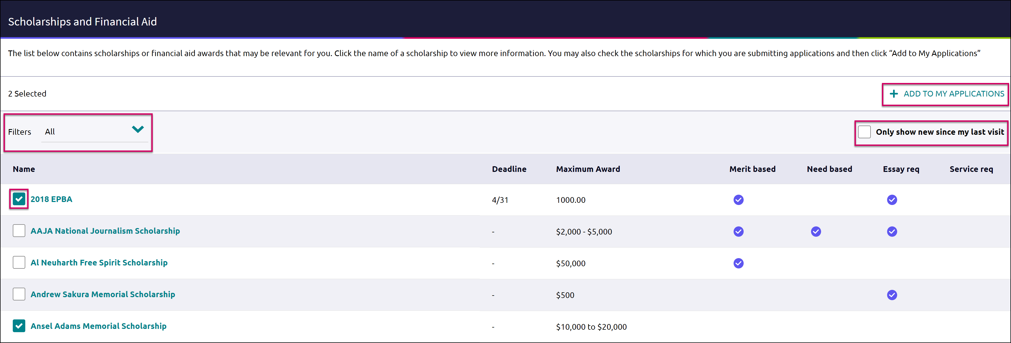

Scholarship Match
This list shows scholarships that may be a suitable match for you based on the requirements such as gender, ethnicity, GPA, etc. If your school did not did not enter any qualifications for a scholarship, the matching criteria will be labeled as No Restrictions Found. Click the checkmark on a scholarship you have or will apply to and then choose Add to My Applications.
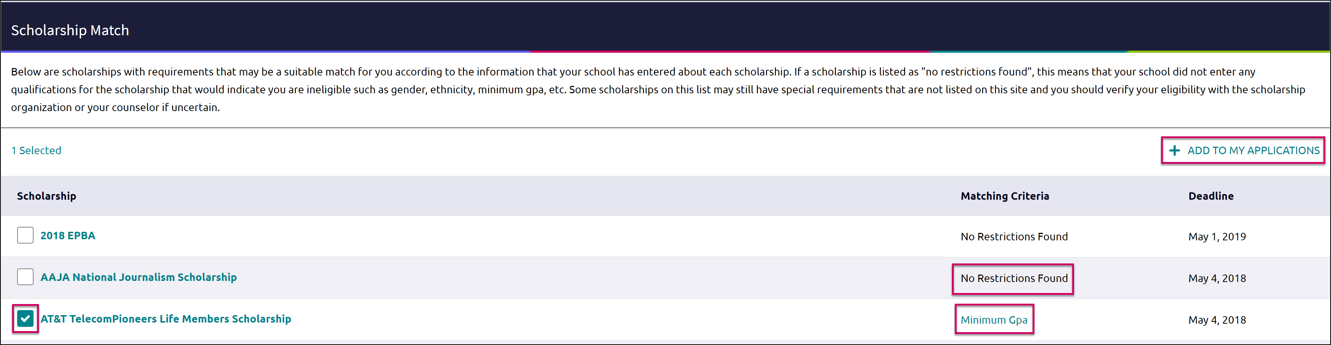

National Scholarship Search
An external site hosted by Sallie Mae that provides a list of potential scholarship matches based on your personal criteria from Naviance Student. If you want to change information that is driving your matches, use the Edit Profile tab to make any updates. You can use this site to create a set of Favorites (separate from those in Naviance Student).
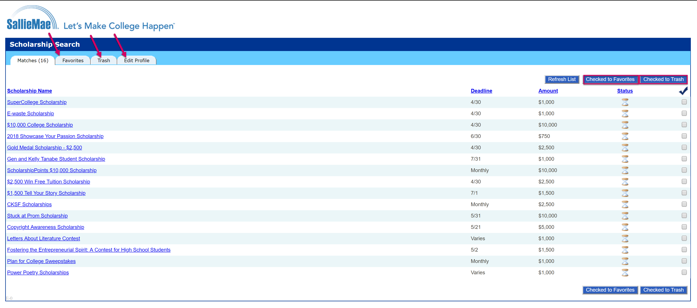

Tracking Scholarships

Scholarships I’m Applying To
Use the Scholarships I’m Applying To as a way to keep a list of scholarships you have applied to along with the award value. You can use the scholarship list and matches to save items here or enter the scholarships manually.
To manually add scholarships to the list:
- Click the pink plus (+) icon to add a scholarship.
- Enter the information for the scholarship including name, $ awarded and award status.
- Click Add Scholarships.
